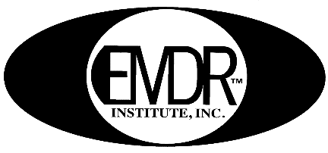 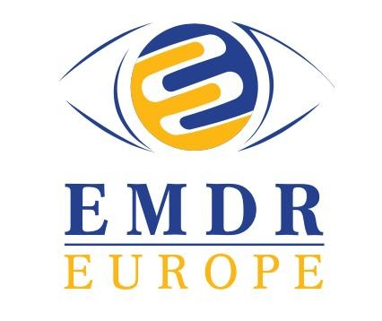

**EMDR Training in English**

**Taught by Gary Quinn, M.D.**

**This training course is open to mental health professionals**

EMDR is a comprehensive, integrative psychotherapy that addresses the experiential contributors of a wide range of pathologies.

EMDR has been found to be effective in PTSD, Addiction, Anxiety, Depression, Panic, Dissociative Disorders, and more.

**EMDR has proven to be effective and efficient in treating soldiers, victims, and others of October 7th.**

Dr. Gary Quinn is Director of the EMDR Institute of Israel ([www.emdr-israel.org](http://www.emdr-israel.org/)) and has over 30 years of experience treating patients with EMDR.

He is an EMDR Trainer of trainers in Israel, Europe, Asia, and New Zealand.

Dr. Quinn developed ISP® Immediate Stabilization Procedure used by therapists and first responders after man-made and natural disasters.

**Basic Training is a 2-part course**

**Part 1**

* Explanation of EMDR therapy
* Theories of how EMDR might work
* Adaptive Information Model (AIP) a working model explaining EMDR
* Preparation and stabilization strategies
* The Eight phases of EMDR therapy
* Working with children
* Recent events protocol.

**Part 2**

* Advanced case treatment planning strategies
* Strategy for clients with complex issues
* Cognitive interweaves.
* Additional consideration with:
  + Psychological reactions to illness and injury
  + Grief and Mourning
  + Anxiety and Phobias
  + Addictions
  + Dissociation
  + Combat veterans and First responders
  + Couples

Course includes an English manual, lectures, videotapes, and supervised practice sessions.

**Part 1**

Training: Jan 5th,6th,12th,13th 2025

Course and Practicum in Jerusalem: 9:00 – 18:00

Consultation groups on Zoom: Jan 27, Feb,10, 24, 2025

18:00-20:15

**Part 2**

Training: March 2nd ,3rd ,9th ,2025

Course and Practicum in Jerusalem: 9:00 – 18:00

Consultation groups on Zoom: Mar 24, Apr.21, May 5, 19, June 9, 2025, 18:00-20:15

**PRICE**: **7,000** NIS

**Discount of 350 NIS for early registration by December 15, 2024**

**For more information and registration: Iris**

**(052) 503-0877**

[EMDR.Institute.of.Israel@gmail.com](mailto:EMDR.Institute.of.Israel@gmail.com)

Registration fee 250 non-refundable